**A Project Report on**

**“Foot Step Energy Generation Using Piezoelectric Sensors and Arduino”**

**Submitted By:**

**Mr. Pradnesh A. Shevantikar (PRN: 2021032500011281)**

**Mr. Om R. Dixit (PRN: 2020032500185247)**

**Mr. Abhishek S. Korachagao (PRN: 2021032500011331)**

**Mr. Avinash P. Udata (PRN: 2021032500011362)**

**Mr. Vinayak R. Jadhav (PRN: 2021032500011385)**

**Under the Guidance of**

**Mr. P.D. Mane**

**in partial fulfilment for the award of the Degree**

**of**

**Bachelor of Technology**

**In**

**Department of Computer Science and Engineering**

**At**



**Shri Vithal Education and Research Institutes,**

**College of Engineering, Pandharpur**

**Affiliated to Punyashlok Ahilyadevi Holkar Solapur University, Solapur**

**2023-24**



**SVERI’s College of Engineering, Pandharpur**

**Certificate**

This is to certify that the project report entitled **“Foot Step Energy Generation using Piezoelectric Sensors and Arduino”** is submitted by **Mr. Pradnesh Amar Shevantikar** for partial fulfilment Bachelor of Technology in Computer Science and Engineering as per requirement of Punyashlok Ahilyadevi Holkar Solapur University, Solapur for the academic year 2023-2024.

(Mr. P. D. Mane) (Mr. P. D. Mane)

Project Guide Project Coordinator

(Dr. S. P. Pawar) (Dr. B. P. Ronge)

HOD CSE Principal

External Examiner

**Acknowledgement**

We are pleased to acknowledge **Dr. S. P. Pawar** (HOD CSE) for her valuable guidance during the course of this project work. We extend our sincere thanks to **Mr. P. D. Mane** who continuously helped us throughout the project and without his guidance, this project would have been an uphill task.

We are so grateful to other members of the CSE faculty members and technical staff who cooperated with us regarding some issues.

Last but not least, Ms. S. D. Wadekar supervisor of Digital Techniques Lab and Ms. T. A. Dhumal supervisor of Project Lab as the case may be for project sessions, also cooperated with us nicely for the smooth development of this project. I would like to thank my parents and friends who helped me a lot in executing this project within the limited time frame.

Signature :

(Mr. Shevantikar P. A. Sign. .......…………. )

(Mr. Dixit O. R. Sign. ……………… )

(Mr. Korachagao A. S. Sign. ……………… )

(Mr. Udata A. P. Sign. ……………… )

(Mr. Jadhav V. R. Sign. ……………… )

**Table of Contents**

**Title Page 1**

**Certificate 2**

**Acknowledgement 3**

**Table of Contents 4**

**Synopsis 5**

**Abbreviations 10**

**List of Figures 10**

**Cost of components used 11**

**Synopsis**

**Introduction**

Footstep power generation is an innovative technology that converts the mechanical energy generated by human footsteps into electrical energy. It offers a sustainable and eco-friendly solution for generating electricity in various settings, such as urban environments, public spaces, and high-traffic areas.

The fundamental principle of footstep power generation revolves around utilizing specialized materials and devices, often incorporating piezoelectric components. Here's a concise explanation of how it works:

1. **Piezoelectric Materials:** In areas where people walk, piezoelectric materials are strategically placed. These materials have the unique property of generating an electric charge when subjected to mechanical stress or pressure.
2. **Mechanical Energy Conversion:** When individuals walk over these piezoelectric tiles or surfaces, the pressure from their footsteps causes the materials to deform slightly. This deformation results in the generation of a small electric charge as a direct consequence of the mechanical force applied.
3. **Application Public Spaces**: Footstep power generation is commonly used in public spaces with high foot traffic, such as shopping malls, airports, train stations, and bus terminals. The energy generated can be used to power lighting, charging stations, or other amenities within these areas.
4. **Urban Infrastructure:** It can be integrated into sidewalks, plazas, and pedestrian walkways in urban areas. This not only generates electricity but also encourages pedestrians to walk and exercise, promoting a healthier lifestyle.
5. **Transit Systems:** Footstep power generation can be incorporated into transportation systems, such as train stations and subway platforms. The energy generated can help offset the power needed for lighting, escalators, and other transit infrastructure.

**Literature review**

Introduction: Footstep power generation is a promising and innovative approach to harnessing renewable energy from human motion. This review aims to provide a comprehensive overview of the key developments, challenges, and applications in the field of footstep power generation.

**1. Historical Perspective**: Early studies on footstep power generation can be traced back to the late 20th century. Researchers initially focused on piezoelectric materials for energy conversion, laying the foundation for subsequent advancements in the field.

**2. Energy Conversion Mechanisms**: The primary energy conversion mechanism employed in footstep power generation is piezoelectricity. Researchers have explored various piezoelectric materials, such as piezoelectric ceramics, polymers, and nanomaterials, to enhance energy conversion efficiency.

**3. Technological Innovations**: Recent studies have introduced novel techniques to improve the efficiency and practicality of footstep power generation. These innovations include energy harvesting circuits, smart flooring systems, and energy storage solutions.

**4. Application Areas**: Footstep power generation has found applications in diverse settings, including urban environments, transportation hubs, healthcare facilities, and educational institutions. Notable examples include subway stations in Tokyo and the Pavegen system installed at airports.

**5. Challenges and Limitations**: Despite its potential, footstep power generation faces several challenges. These include scalability issues, material durability, and the need for standardized testing methods. Researchers are actively addressing these challenges to promote wider adoption.

**6. Environmental Impact**: One of the key advantages of footstep power generation is its positive environmental impact. By reducing reliance on non-renewable energy sources, it contributes to a cleaner and more sustainable future.

**7. Cost-Effectiveness**: The cost-effectiveness of footstep power generation systems remains a topic of debate. Initial installation costs and maintenance expenses can be high, but the long-term benefits in terms of energy savings and reduced carbon emissions make a compelling case.

**8. Future Prospects**: As the field of footstep power generation continues to evolve, future prospects appear promising. Emerging technologies, such as triboelectric nanogenerators and flexible piezoelectric materials, hold the potential to overcome existing limitations and expand the range of applications.

**Problem Statement**

Footstep power generation technologies have garnered attention as a sustainable and eco-friendly means of harvesting energy from human movement. However, several challenges and issues hinder their widespread adoption and effectiveness. This problem statement outlines the key problems faced by footstep power generation technologies.

**Objectives**

The objectives for advancing footstep power generation technologies encompass various aspects, from technical advancements to broader societal and environmental goals. These objectives aim to drive innovation and promote the adoption of this sustainable energy source. Here are the key objectives:

1. Improve Energy Conversion Efficiency

2. Enhance Scalability and Integration

3. Ensure Durability and Longevity

4. Optimize Cost-effectiveness

5. Establish Standards and Certification

6. Encourage User Acceptance and Behaviour Change

7. Conduct Comprehensive Environmental Assessments

8. Enable Grid Integration

1. **Introduction 12**
   1. Introduction ……………………………………………..12
   2. Motivation ………………………………………………13
   3. Need of work ……………………………………………14
   4. Objectives…………………………………….………….15
2. **Software Implementation 16**
3. **Need of System 16**
4. **Literature Survey 18**
   1. Existing System………………………………………….18
   2. Problem Definition……………………………………....19
   3. Proposed System……………………………………..….20
   4. Advantage of Proposed System…………………………22
5. **Components 29**
6. **Methodology/Techniques Used 36**
7. **Code Block 38**
8. **Experimental Results/Outputs 39**
9. **Conclusion and Future Scopes 42**
10. **References 44**
11. **Research Paper Publication Certificates 45**
12. **Research Paper 50**
13. **Sponsorship Letter 52**

**Abbreviation**

FEHS: Footstep Energy Harvesting System

PS: Piezoelectric Sensors

SES: Sustainable Energy Solutions

EH: Energy Harvesting

MCU: Microcontroller Unit

LED: Light Emitting Diode

USB: Universal Serial Bus

AC: Alternating Current

DC: Direct Current

IoT: Internet of Things

LAN: Local Area Network

LEDs: Light Emitting Diodes

Vcc: Voltage at the Common Collector

GND: Ground

RFID: Radio-Frequency Identification

AI: Artificial Intelligence

ML: Machine Learning

**List of Figures**

* + 1. Block diagram of system
    2. Piezoelectric sensor working
    3. Piezoelectric sensors
    4. Arduino uno board
    5. At mega 328 pin diagram
    6. Lithium ion Battery

**Units**

1. V - Volts (Voltage)
2. A - Amperes (Current)
3. Ω - Ohms (Resistance)
4. W - Watts (Power)
5. mAh - Milliampere-hours (Battery Capacity)
6. μF - Microfarads (Capacitance)
7. Hz - Hertz (Frequency)
8. °C - Degrees Celsius (Temperature)
9. g - Grams (Mass) m - Meters (Length)
10. s - Seconds (Time) J - Joules (Energy)
11. Wh - Watt-hours (Energy)
12. dB - Decibels (Sound level)
13. Lux - Lux (Illuminance)
14. A/m² - Amperes per square meter (Current density)
15. V/m - Volts per meter (Electric field strength)
16. C - Coulombs (Electric charge)
17. F - Farads (Capacitance)
18. Tesla (T) - Magnetic flux density

**Cost Of components used**

|  |  |
| --- | --- |
| **Components** | **Price** |
| 1. **Arduino uno board** | **Rs. 550 /-** |
| 1. **Piezoelectric Sensor** | **Rs. 130 /-** |
| 1. **Charging Module** | **Rs. 40 /-** |
| 1. **Power bank Module** | **Rs. 50 /-** |
| 1. **Slide Switch** | **Rs. 10 /-** |
| 1. **Lithium-ion Battery** | **Rs. 90 /-** |
| 1. **Voltmeter** | **Rs. 300 /-** |
| 1. **Electronic Accessories and Other equipment** | **Rs. 200 /-** |
| **Total** | **Rs. 1370** |

**Chapter 1**

**Introduction**

* 1. **Introduction**

This footsteps power generation project design is a system that Generates voltages by the humane footsteps force. Using piezoelectric sensors sources and stores it for usage. The system will have piezoelectric sensors that will convert the footsteps force and pressure into electrical signals. It will fully depend on the human footsteps pressure and convert it into useful power. This project uses simple walk mechanism such as steps by human. The electronic devices also increased. Power generation using conservative methods deficient. A working model of Footstep Power Generation is demonstrated in this project, the basic working of this model has been presented as a block diagram (Fig.1). To implement this model four piezoelectric sensor that are connected in series to increase the voltage output this sensor generates AC voltage which is transferred to the bridge rectifier. The output voltage from the sensor can be of two types because it produces AC voltage: There is a necessity a different power generation method. At the same time the energy is wasted due to human locomotion and many ways. To overcome this problem, the energy wastage can be converted to usable form using the piezoelectric sensor his sensor converts the pressure on it to a voltage. So, by using this is energy saving method that is the footstep power generation system we are generating power. This project is used to generate electricity voltage using footstep force so, these systems are placed in public places where people walk and those have to travel on this system to get through the entrance or exists. Then, these systems may generate voltage on each and every step of a foot. The proposed system works as a medium to generate power using force. This project is very useful in public places like bus stands, theaters, railway stations, shopping malls.

In an era marked by the imperative need for sustainable energy solutions, the exploration of innovative and eco-friendly power generation methods has gained significant attention. One promising avenue is the harnessing of footstep energy through the integration of piezoelectric sensors into flooring surfaces. This research introduces a Smart Footstep Energy Harvesting System with a unique feature — the ability to identify and signal sensor failures or damages, thereby contributing to the advancement of reliable and maintainable energy harvesting infrastructure.

The primary goal of this project is to develop a self-sufficient and efficient system that transforms the mechanical energy from footsteps into electrical power. The core components of the system include strategically placed piezoelectric sensors, an Arduino microcontroller for signal processing and energy management, and a rechargeable battery for storing the harvested energy. To address the challenge of sensor maintenance, LEDs are integrated with each sensor, acting as visual indicators for sensor status.

The inclusion of LED indicators facilitates easy identification of sensor failures, a feature inspired by the convenience provided by LAN ports on networking equipment. In the event of a damaged or failed sensor, the corresponding LED illuminates, allowing users to pinpoint the location of the issue promptly. This feature not only streamlines maintenance efforts but also enhances the overall user experience by ensuring the system's reliability.

The research investigates the practical implementation of the Smart Footstep Energy Harvesting System, exploring its efficiency in diverse environmental conditions and its adaptability to real-world scenarios. The paper delves into the intricacies of the Arduino code, detailing the monitoring algorithm that activates LEDs when sensor values fall below a predefined threshold. Furthermore, the study evaluates the system's potential applications, emphasizing its role in sustainable power generation for small electronic devices and its integration into smart infrastructure.

As the demand for sustainable energy solutions continues to rise, this research contributes to the ongoing discourse on energy harvesting technologies. The Smart Footstep Energy Harvesting System with Sensor Failure Identification not only aligns with the principles of green energy but also introduces a user-centric approach to infrastructure maintenance. The subsequent sections of this paper will delve into the system's design, implementation, and experimental evaluations, offering valuable insights into the effectiveness and viability of this innovative energy harvesting solution.

* 1. **Motivation**

The motivation behind a footstep energy generation project can stem from various factors, including:

1. **Renewable Energy Generation**

Footstep energy generation harnesses the kinetic energy produced by human footsteps, converting it into electricity. The primary motivation may be to contribute to renewable energy sources, reducing reliance on fossil fuels and decreasing carbon emissions.

1. **Sustainability**

Promoting sustainability is often a key driver behind such projects. By utilizing a readily available resource like human movement, footstep energy generation reduces environmental impact and promotes more eco-friendly practices.

1. **Energy Efficiency**

Footstep energy generation can be integrated into public spaces like sidewalks, train stations, or shopping malls, where there is high foot traffic. By capturing this otherwise wasted energy, the project aims to improve energy efficiency and reduce overall consumption.

1. **Community Engagement**

Implementing footstep energy generation projects can engage communities in sustainable practices. It serves as a tangible demonstration of how individual actions can contribute to larger environmental goals, fostering a sense of ownership and responsibility among participants.

1. **Innovation and Technology Development**

Such projects often involve innovative technology development, driving advancements in energy harvesting and storage systems. The motivation may include promoting research and development in renewable energy technologies and encouraging innovation in urban infrastructure.

1. **Public Health and Well-being**

Encouraging people to walk more by providing incentives such as footstep energy generation can have positive implications for public health. It promotes physical activity and can contribute to reducing sedentary lifestyles, thus improving overall well-being.

1. **Urban Planning and Design**

Footstep energy generation projects can be integrated into urban planning and design strategies to create more sustainable and resilient cities. By incorporating renewable energy solutions into infrastructure, cities can reduce their carbon footprint and enhance their attractiveness to residents and visitors alike.

1. **Educational and Awareness Purposes**

These projects can serve as educational tools to raise awareness about energy conservation, renewable energy technologies, and sustainable living practices. They provide opportunities for learning and engagement, particularly among students and the general public.

* 1. **Need of work**

The need for piezoelectric sensor-based footstep energy generation projects stems from several key factors:

1. **Sustainability**

With increasing concerns about environmental sustainability and the depletion of traditional energy sources, there is a growing need to explore alternative sources of energy. Piezoelectric footstep energy generation offers a renewable and sustainable solution by harnessing the kinetic energy generated by human movement.

1. **Energy Harvesting**

Footstep energy harvesting has the potential to capture energy that would otherwise be wasted. In urban environments, where foot traffic is high, this energy source can be significant and contribute to reducing reliance on non-renewable energy sources.

1. **Resource Efficiency**

Unlike solar or wind energy, which are intermittent and dependent on weather conditions, footstep energy harvesting can be more consistent and reliable in certain settings, such as crowded pedestrian areas or high-traffic public spaces.

1. **Off-grid Applications**

In remote or off-grid locations where access to conventional power sources is limited, piezoelectric footstep energy generation can provide a sustainable power solution for lighting, communication, or small-scale electronic devices.

1. **Infrastructure Integration**

Integrating piezoelectric energy harvesting systems into existing infrastructure, such as sidewalks, pavements, or flooring in public buildings, offers a seamless way to generate electricity without disrupting daily activities.

1. **Innovation and Research**

Research in this field contributes to advancements in piezoelectric materials, sensor technologies, and energy conversion methods. This innovation can lead to more efficient and cost-effective energy harvesting systems with broader applications.

1. **Environmental Impact**

By reducing the reliance on fossil fuels and minimizing carbon emissions, piezoelectric footstep energy generation projects contribute to mitigating climate change and reducing environmental pollution.

* 1. **Objectives**  
     The objectives of a piezoelectric sensor-based footstep energy generation project typically include:

1. **Design and Implementation**

Develop a robust and efficient system for harvesting energy from footstep vibrations using piezoelectric sensors. This involves designing the layout of the sensors, selecting appropriate materials, and implementing the necessary circuitry for energy conversion and storage.

1. **Optimization of Energy Harvesting Efficiency**

Explore various parameters such as sensor placement, material properties, and circuit design to maximize the conversion efficiency of mechanical energy into electrical energy. This may involve experimentation and calibration to achieve the highest possible power output from the system.

1. **Evaluation of System Performance**

Conduct thorough testing and analysis of the energy harvesting system under different conditions, such as varying footstep forces, frequencies, and environmental factors. Measure key performance metrics such as voltage output, current output, and overall power generation capacity.

1. **Assessment of Durability and Reliability**

Evaluate the long-term durability and reliability of the system components, including the piezoelectric sensors, conditioning circuits, and energy storage devices. Identify any potential failure points or degradation mechanisms and propose solutions to enhance the system's lifespan.

1. **Application Feasibility**

Assess the feasibility of integrating the energy harvesting system into real-world applications, such as pedestrian walkways, public buildings, or outdoor infrastructure. Consider factors such as cost-effectiveness, scalability, and compatibility with existing infrastructure.

1. **Exploration of Potential Applications**

Investigate potential uses and applications of the harvested energy, such as powering streetlights, LED displays, wireless sensors, or charging stations for electronic devices. Explore innovative ways to utilize the generated electricity to meet specific energy needs.

1. **Documentation and Knowledge Sharing**

Document the design process, experimental findings, and lessons learned throughout the project. Produce a comprehensive project report to disseminate knowledge and insights gained from the research, contributing to the broader scientific community.

**Software Implementation**

This project we are using software a program for Arduino hardware may be any programming language with compilers that produce Atmel provides a development environment for their 8bit ADC and 32-bit ADC based microcontrollers: The Arduino IDE supports the languages C and C++ using special rules of code structuring. We are using software in Arduino because of total input and output show in display how much voltage produced by the human steps to help of c Arduino software.

**Need of System**

A day by day the population of the country increased and the requirement of the power is also increased. The peoples at the same time wastage of energy that also increased in many ways. So, reforming this energy back to usable form is the solution. That’s why we want new types of technology to be developed.

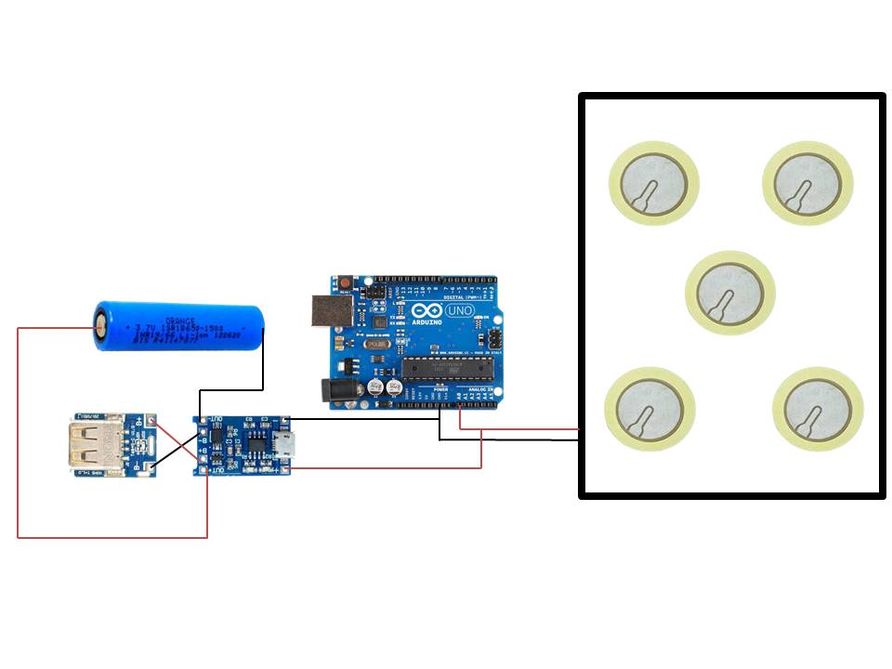

**Fig 1. Block Diagram of System**

**Chapter 2**

1. **Literature Survey**

According to the author P. Venkatesh, in this paper, we have presented the design of power generation using footstep based on available piezoelectric sensors. Human race requires energy at very rapid rate for their living and wellbeing from the time of their arrival on this planet, because of this reason the power resources have been worn out and enervated. Proposal for the employment and application of extravagant energy in foots of human is very much to the purpose for extremely populated nations like China and India. Sarat Kumar Sahoo discussed about the foot step power generation. Creating electrical energy in this project using a non-traditional way of just stepping on the footprints. At this time, non-conventional energy systems are desperately needed. Steps-based energy generating does not require any fuel input to create power. This for system according of R. Jai Rajesh: this article it is suggested that voltage should be produced using footstep power. The proposed device acts as a tool by using pressure to generate electricity for public locations, this article is very useful. Therefore, these devices are installed in public situations where people are walking, and they have to ride on this device in order to pass through or live. Such systems will then produce voltage about each and every move of a foot alternative source must be discovered, many people propose for solar energy, but it is going to be a costliest affair, those moreover availability of solar energy is poor particularly in rainy & winter seasons, as a result it is not dependable. Hence an alternative cheapest electricity generated by the sensors.

* 1. **Existing System**

The existing system of piezoelectric sensor-based footstep energy generation typically involves the following components and processes:

1. **Piezoelectric Sensors**

These sensors are embedded in the flooring or pavement where foot traffic occurs. Piezoelectric materials, such as lead zirconate titanate (PZT) or polyvinylidene fluoride (PVDF), are commonly used due to their ability to generate electrical charge when subjected to mechanical stress.

1. **Energy Harvesting Circuitry**

The electrical charge generated by the piezoelectric sensors is converted into usable electrical energy using conditioning circuits. These circuits typically include rectifiers to convert the AC voltage generated by the sensors into DC voltage, as well as voltage amplifiers and regulators to optimize the power output.

1. **Energy Storage System**

The harvested electrical energy is stored in batteries, supercapacitors, or other energy storage devices for later use. This ensures that the generated energy can be utilized even when foot traffic is low or absent.

1. **Monitoring and Control Systems**

Some implementations may include monitoring and control systems to optimize energy harvesting efficiency and manage the stored energy. This could involve real-time monitoring of foot traffic patterns, adjusting sensor sensitivity, or controlling the charging and discharging of energy storage devices.

1. **Integration with Infrastructure**

The energy harvesting system is integrated into existing infrastructure, such as pedestrian walkways, pavements, or flooring in public buildings. The goal is to seamlessly capture energy from footstep vibrations without disrupting the normal usage of the space.

1. **Applications**

The harvested energy can be utilized for various applications, including lighting, signage, electronic displays, wireless sensors, or charging stations for electronic devices. The versatility of the system allows for customization to meet specific energy needs in different environments.

1. **Challenges**

Despite the potential benefits, there are challenges associated with existing piezoelectric footstep energy generation systems, including low energy conversion efficiency, durability issues with piezoelectric materials, and the need for optimization and calibration to maximize performance.

* 1. **Problem Definition**

The problem definition for a piezoelectric sensor-based footstep energy generation project can be outlined as follows:

**Problem Statement**

In urban environments and high-traffic areas, there exists a significant amount of mechanical energy generated by human footstep vibrations. This mechanical energy, if harnessed efficiently, could serve as a sustainable and renewable source of electrical power for various applications. However, the current challenge lies in developing an effective system capable of capturing and converting this mechanical energy into usable electrical energy with high efficiency and reliability.

**Key Issues:**

1. **Low Energy Conversion Efficiency**

Existing piezoelectric footstep energy generation systems often suffer from low efficiency in converting mechanical energy into electrical energy. This inefficiency results in suboptimal power output and limits the practicality of such systems for real-world applications.

1. **Durability and Reliability**

Piezoelectric materials used in these systems may experience degradation over time due to mechanical stress, environmental factors, or material fatigue. Ensuring the long-term durability and reliability of the system components is essential for sustainable operation.

1. **Optimization of Sensor Placement and Configuration**

The placement and configuration of piezoelectric sensors within the flooring or pavement significantly impact the energy harvesting efficiency. Finding the optimal sensor layout and calibration parameters to maximize power generation while minimizing interference and false readings is a critical challenge.

1. **Integration with Existing Infrastructure**

Integrating energy harvesting systems into existing infrastructure poses logistical challenges, including retrofitting, maintenance, and compatibility with different types of flooring materials. The system design should account for these factors to facilitate seamless integration and minimize disruption to normal activities.

1. **Cost-effectiveness and Scalability**

Developing cost-effective solutions that can be scaled up for widespread deployment is essential for the practical implementation of piezoelectric footstep energy generation systems. Balancing the upfront installation costs with long-term energy savings and environmental benefits is a key consideration.

**Objective**

The primary objective of this project is to design, implement, and evaluate a piezoelectric sensor-based footstep energy generation system that addresses the aforementioned challenges. The project aims to optimize energy harvesting efficiency, enhance durability and reliability, identify optimal sensor configurations, and demonstrate the feasibility of integrating the system into existing infrastructure for sustainable energy generation.

* 1. **Proposed System**

The proposed system for piezoelectric sensor-based footstep energy generation aims to address the challenges outlined in the problem definition while maximizing energy harvesting efficiency and reliability. The proposed system consists of several key components and features:

1. **Enhanced Piezoelectric Sensors**

Utilization of high-quality piezoelectric materials with superior energy conversion properties, such as lead zirconate titanate (PZT) or polyvinylidene fluoride (PVDF). These sensors are designed to efficiently convert mechanical energy from footstep vibrations into electrical energy.

1. **Optimized Sensor Configuration**

The placement and configuration of piezoelectric sensors within the flooring or pavement are carefully optimized to maximize energy harvesting efficiency. This involves strategic positioning of sensors in high-traffic areas and adjusting sensitivity settings to capture a broad range of footstep forces and frequencies.

1. **Advanced Conditioning Circuitry**

Integration of sophisticated conditioning circuits that efficiently convert the AC voltage generated by the piezoelectric sensors into stable DC voltage. This includes precision rectifiers, voltage amplifiers, and filtering mechanisms to ensure optimal power output and minimize signal distortion.

1. **Energy Storage and Management**

Implementation of robust energy storage systems, such as lithium-ion batteries or supercapacitors, to store the harvested electrical energy for later use. Intelligent energy management algorithms are employed to optimize charging and discharging cycles, ensuring reliable power supply even during periods of low foot traffic.

1. **Durability and Reliability Enhancements**

Incorporation of protective coatings, encapsulation techniques, and robust housing materials to enhance the durability and reliability of the system components. This ensures long-term operation in diverse environmental conditions and minimizes degradation due to mechanical stress or environmental factors.

1. **Smart Monitoring and Control**

Integration of monitoring and control systems that provide real-time feedback on energy harvesting performance, system health, and energy usage. This includes remote monitoring capabilities, fault detection algorithms, and adaptive control mechanisms to optimize system operation and diagnose potential issues proactively.

1. **Scalability and Integration**

Designing the system with scalability in mind to facilitate easy deployment and integration into existing infrastructure. Modular components and standardized interfaces enable seamless installation and expansion of the energy harvesting system in various urban and public spaces.

1. **Cost-effectiveness and Sustainability**

Balancing performance requirements with cost-effectiveness to ensure the practicality and affordability of the proposed system. Leveraging advances in materials science, electronics, and manufacturing processes to minimize production costs while maximizing energy yield and environmental sustainability.

* 1. **Advantage of Proposed System**  
      The proposed system for piezoelectric sensor-based footstep energy generation offers several advantages over existing systems:

1. **High Energy Conversion Efficiency**

By utilizing advanced piezoelectric materials and optimized sensor configurations, the proposed system achieves higher energy conversion efficiency, maximizing the amount of electrical energy harvested from footstep vibrations.

1. **Reliability and Durability**

Incorporation of enhanced durability features, such as protective coatings and robust housing materials, ensures the long-term reliability and performance of the system, even in challenging environmental conditions.

1. **Optimized Energy Management**

The system includes intelligent energy management algorithms that optimize charging and discharging cycles of the energy storage system, ensuring reliable power supply and maximizing energy utilization efficiency.

1. **Scalability and Integration**

Designed with scalability in mind, the proposed system can be easily integrated into existing infrastructure, allowing for seamless deployment in various urban and public spaces. Modular components and standardized interfaces facilitate straightforward installation and expansion as needed.

1. **Real-time Monitoring and Control**

Integration of smart monitoring and control systems provides real-time feedback on energy harvesting performance and system health. This enables proactive maintenance and optimization of system operation, enhancing overall efficiency and reliability.

1. **Cost-effectiveness**

Despite its advanced features, the proposed system balances performance requirements with cost-effectiveness, leveraging advancements in materials science, electronics, and manufacturing processes to minimize production costs while maximizing energy yield.

1. **Sustainability**

By harnessing renewable energy from footstep vibrations, the proposed system contributes to sustainability efforts by reducing reliance on non-renewable energy sources and minimizing carbon emissions. It offers a clean and environmentally friendly solution for powering various applications in urban environments.

1. **Versatility**

The system's versatility allows it to be adapted for a wide range of applications, including lighting, signage, electronic displays, wireless sensors, and charging stations for electronic devices. Its flexibility and adaptability make it suitable for diverse urban environments and use cases.

* 1. **Prototype System**

The piezoelectric material converts the pressure, stress applied to the material into electrical energy. The source of stress is from the weight of the people stepping on the stairs. As the output voltage from a single piezo-film was extremely low, thus combination of few piezoelectric is used. Two types’ possible connections can be done parallel connections and series connections. The output of the piezoelectric material is not a regulated one, so variable to linear voltage converter circuit rectifier is used. Ac ripple neutralizer is the circuit used to reduce the ripples from the piezoelectric output. The AC ripple neutralizer consists of rectifier and ripple filter. Again AC ripples are filtered out using ripple filter and it is used to filter out any further variations in the output and then it can be pass through regulator in order to regulate. The output of the voltage regulator is given to the unidirectional current controller. Unidirectional current controller means it allows flow of current in only one direction.

* 1. **Working**

Piezoelectric material generate electricity when pressure or vibration or any kind of force is applied on the surface of piezoelectric material. We will apply pressure on piezoelectric material so that it can generate electricity. The output generated by piezoelectric material are in the AC voltage so to store output we have to convert it into DC voltage. For that we use rectifier that converts AC voltage to DC voltage and with the help of rectifier we will convert AC source to DC source. Then we will store that energy into battery by applying diode so that current can flow in unidirectional. And finally we use led to glow. And we also connected multimeter to the rectifier so that we can measure voltages and current generated from them.

1. **Piezoelectric Sensor Reading:**
   * The Arduino continuously reads the analog voltage value from the piezoelectric sensor connected to Analog Pin A0.
   * When pressure is applied to the sensor (e.g., someone steps on it), it generates a voltage signal, which is detected by the Arduino.
2. **Voltage Conversion:**
   * The Arduino converts the sensor reading (which is in analog voltage) to a digital value and then calculates the corresponding voltage level.
3. **Battery Charging Control:**
   * If the voltage reading from the sensor is greater than 0 (indicating pressure is applied), the Arduino enables the battery charging module by setting the designated digital pin (Pin 3) to HIGH.
   * This allows the battery charging module to start charging the connected battery.
4. **Battery Charging:**
   * The battery charging module regulates the charging current and voltage to safely charge the battery.
   * Charging proceeds as long as the sensor detects pressure and the Arduino enables the charging module.
5. **Charging Disable:**
   * When pressure is no longer applied to the sensor (e.g., when the person stops stepping on it), the voltage reading from the sensor drops to 0.
   * The Arduino then disables the battery charging module by setting the designated digital pin (Pin 3) to LOW.
   * Charging stops, and the battery remains in a charged state until pressure is detected again.

This system effectively charges the battery using the energy generated by stepping on the piezoelectric sensor. It's a simple energy harvesting setup that converts mechanical energy (footstep pressure) into electrical energy (battery charging) using the piezoelectric effect.

* 1. **Construction**

We construct the piezoelectric tile with the help of wood block. On the surface 2nd layer of woodblock we place piezoelectric material. As we know by research study that pzt is best suitable for this project. We give connection to piezoelectric material series-parallel. We know from research paper so we use both series parallel connection so that the optimum amount of current and voltage can be generated. After the completion of frame setup and piezoelectric connection setup we will connect the two terminal of piezoelectric material to full-wave bridge rectifier circuit. So that the ac voltage from piezoelectric material can converted in dc voltage. The force on piezoelectric material can be moving people or vehicle or any kind of pressure or vibration. After the rectification we will measure dc voltage and current with the help of multimeter. And then the dc output is stored into the battery with the help of unidirectional diode so that current can flow in one direction i.e. from piezoelectric material to the battery.

**Components Needed**

1. **Arduino Board**

Any Arduino board with analog and digital pins, such as Arduino Uno.

1. **Piezoelectric Sensor**

One piezoelectric sensor for detecting footstep pressure.

1. **Battery**

A rechargeable battery, preferably a lithium-ion (Li-ion) or lithium-polymer (LiPo) battery compatible with the TP4056 charging module.

1. **TP4056 Charging Module**

A TP4056-based charging module for charging the battery. This module typically includes components like a charging IC, MOSFET, and associated resistors and capacitors.

1. **Jumper Wires**

To make the necessary connections between components.

**Construction Steps**

1. **Prepare Components:**
   * Gather all the components listed above.
2. **Connect Piezoelectric Sensor:**
   * Connect the positive terminal of the piezoelectric sensor to Analog Pin A0 of the Arduino board.
   * Connect the negative terminal of the sensor to the ground (GND) pin of the Arduino board.
3. **Connect Battery Charging Module:**
   * Connect the positive terminal of the battery charging module to the positive terminal of the battery.
   * Connect the negative terminal of the battery charging module to the negative terminal of the battery.
   * Connect the OUT+ pin of the battery charging module to Digital Pin 3 (or any other available digital output pin) of the Arduino board.
   * Connect the GND pin of the battery charging module to the ground (GND) pin of the Arduino board.
4. **Check Connections:**
   * Double-check all connections to ensure they are correct and secure. Incorrect connections can lead to malfunction or damage to components.
5. **Upload Arduino Code:**
   * Upload the provided Arduino code to your Arduino board using the Arduino IDE.
   * Make sure to select the correct board and COM port in the Arduino IDE before uploading the code.
6. **Power Up the System:**
   * Power up the Arduino board using a USB cable connected to your computer or an external power source (e.g., battery or DC adapter).
7. **Test the System:**
   * Apply pressure to the piezoelectric sensor (e.g., step on it) to simulate footstep pressure.
   * Verify that the battery charging module starts charging the battery when pressure is applied to the sensor.
   * Ensure that the battery charging module stops charging the battery when pressure is released from the sensor.
8. **Enclosure (Optional):**
   * If desired, place the components in a suitable enclosure to protect them from environmental factors and mechanical damage.
   * Ensure proper ventilation and heat dissipation to prevent overheating.
   1. **Actual Setup**

**Step 1: Energy Harvesting Circuit**

1. **Connect Piezoelectric Sensors:**
   * Connect the positive terminal of each piezoelectric sensor to the input of a rectifier circuit.
   * Connect the negative terminal of each sensor to a common ground.
2. **Rectifier Circuit:**
   * Use diodes (such as 1N4007) to create a full-wave or bridge rectifier circuit.
   * This circuit converts the AC output of the piezoelectric sensors into DC voltage.
3. **Filtering and Voltage Regulation:**
   * Add capacitors to the output of the rectifier circuit for smoothing and filtering the DC voltage.
   * Use a voltage regulator (such as LM7805 for 5V output) to regulate the voltage to a stable level suitable for charging the battery.

**Step 2: Battery Charging Circuit**

1. **Battery Selection:**
   * Choose a rechargeable battery compatible with your application, such as a lithium-ion (Li-ion) or lithium-polymer (LiPo) battery.
2. **Charging Controller:**
   * Use a dedicated battery charging IC (such as TP4056) or a microcontroller-based charging controller to manage the charging process.
   * Ensure the charging controller provides features like overcharge protection, over-discharge protection, and temperature monitoring.
3. **Connect Battery:**
   * Connect the positive terminal of the battery to the output of the voltage regulator or charging controller.
   * Connect the negative terminal of the battery to the ground.

**Step 3: Monitoring and Safety Features**

1. **Monitoring:**
   * Implement voltage monitoring to track the battery voltage and ensure it remains within safe operating limits.
   * Monitor the charging current to prevent overcharging and overheating of the battery.
2. **Safety Features:**
   * Add safety features such as overcharge protection, over-discharge protection, and temperature monitoring to ensure safe operation of the battery and charging circuit.

**Step 4: Enclosure and Finalization**

1. **Enclosure:**
   * Place the components in a suitable enclosure to protect them from environmental factors and mechanical damage.
   * Ensure proper ventilation and heat dissipation to prevent overheating.
2. **Testing**
   * Test the complete system to verify its performance and safety features.
   * Monitor the battery voltage, charging current, and energy harvested from the sensors during testing.

By following these steps, you can connect the piezoelectric sensors to a battery for energy storage, while ensuring safe and efficient operation of the system. Adjustments may be needed based on your specific requirements and the characteristics of the components used.

**Chapter 3**

1. **Components**
2. ***Piezoelectric Sensors***

This sensor is most important part in project without these components we are can’t generate and convert this pressure energy into the electrical energy this sensing element that works on the principle of piezoelectric effect is thought as a electricity sensing element A measuring unit for measuring single crystal crystals and bones, which can be obtained from artificial proposals, purchased at stores such as PZT ceramics. Electrical detector features electrical detectors typically measure a combination of physical quantities acceleration and pressure.



**Fig 2. Piezoelectric Sensor Working**

The Piezoelectric ceramics are a type of multi-crystal dielectric with a high dielectric constant and are formed by two processes first, high temperature firing. After 12 firing, they have the characteristic crystal structure shown in, but do not yet exhibit the piezoelectric property because the electrical dipoles within the crystals are oriented at random and the overall the moment of the dipoles is canceled out. To make ceramics piezoelectric they must be polarized.



**Fig 3. Piezoelectric Sensor**

A sensing element that works on the principle of piezoelectric effect is thought as an electricity sensing element. Wherever piezoelectric effect could be a development wherever electricity is generated if mechanical stress is applied to a fabric. Not all materials Flex motions, touch, vibrations, and shock measurement all use piezoelectric sensors. They are used in sectors such as healthcare, aerospace, consumer electronics, and nuclear instrumentation pressure sensor to transfer the applied force to the electrical element. As soon as pressure is applied to the existing thin film the electrical material is charged and voltage begins to be generated. The voltage generated is proportional to the pressure applied.

1. ***Arduino Uno Board***

We are using This Arduino Uno board is a microcontroller board based on the ATmega328. This board using mainly reasons for input output voltage counting in display How much Data can we produced by the walk and how much power we have that’s reason using this Arduino Uno board. Basically, in Arduino board. It has 14 digital input/output pins of which 6 can be used as PWM outputs 6 analog inputs, the board have 16 MHz crystal oscillator, a USB connection, and a power jack, a reset button. It contains everything needed to support the microcontroller; simply connect it to a computer with take a USB cable or power with an AC-to-DC adapter or battery and few seconds to get started.



**Fig 4. Arduino UNO Board**

The input voltage to the Arduino board when it's using an external power source You can supply voltage through this pin, or, if supplying voltage via the power jack, The regulated power supply used to for the on condition The Arduino memory of this Atmega328 Arduino microcontroller have a flash memory-32 KB for storing code SRAM-2 KB EEPROM-1 KB first the Arduino IDE tool is installed in the PC, attach the Arduino board to the computer with the USB cable. This make Arduino board function easy making it available everywhere these boards come with a USB cable for power requirements well as functioning programmer.

*Features of Arduino Uno Board*

• Board of microcontroller: ATmega328

• Board operating voltage: 5v

• Microcontroller clock speed: 16 MHZ

• Digital I/O pins: 6 is Ip /6 is Op

• Dc current per I/O pins: 40mA

• SRAM: 2KB

• EEPROM: 1KB

• Input Voltage: 7-12 v

• Flash Memory is: 32 KB



**Fig 5. At mega 328 Pin Diagram**

1. ***Lithium ion Battery 3.7V***

We are using the lead–battery is a type of rechargeable battery first It is the first type of rechargeable battery ever rechargeable batteries, lead–acid batteries have relatively low energy density. These batteries operate within a very wide range of temperatures, between the freezing point of aqueous H2SO4 solutions and close to the boiling temperature. When operated within this temperature range, they do not need any special temperature control. This is a great advantage of this 12v battery and his most major advantages its save more times power save and low amount of power store from piezoelectric sensors.

The storage battery or secondary battery is such a battery where electrical energy can be stored as chemical energy and this chemical energy is then converted to electrical energy as and when required. The conversion of electrical energy into chemical energy by applying external electrical source is known as charging of battery.

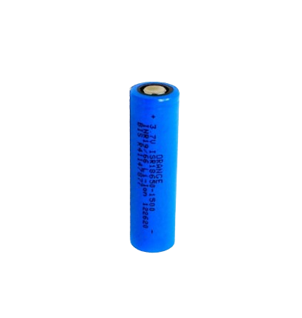

**Fig 6. Lithium ion Battery**

1. ***Led Bulb***

This LED bulb is one types of demonstrate output of generated free of cost energy this blub is the output energy the AC LED is an LED that operates directly out of AC line voltage instead of utilizing a driver to transform the line voltage to direct current dc.

1. ***Application***

Power generation by footstep can be used in most of the places

**1. Colleges and Schools:**

**Entryways and Corridors:** Install piezoelectric sensors on floors in high-traffic areas like entryways, corridors, and staircases.

**Gyms and Sports Facilities:** Incorporate energy-generating flooring in gymnasiums, sports fields, and playgrounds where students are active.

**2. Theatres:**

**Lobby and Aisles:** Install energy-generating flooring in the lobby and along aisles leading to auditoriums. Patrons walking to their seats can contribute to power generation.

**3. Shopping Complexes:**

**Entrances and Exits:** Implement energy-generating flooring at mall entrances and exits, where foot traffic is heavy.

**Escalators and Elevators:** Install sensors near escalators and elevators to capture energy from people going up and down.

**4. Metro and Airport Security Check-in:**

**Security Checkpoints:** Install energy-generating flooring at security checkpoints in metro stations and airports, where there's a constant flow of people.

**5. Speed Breakers:**

**Roadways:** Implement piezoelectric speed breakers on roads leading to and from public places like colleges, schools, shopping complexes, and theaters. Vehicles passing over them generate energy.

**6. Railway Stations:**

**Platforms:** Install energy-generating flooring on platforms where passengers walk to and from trains.

**Concourses:** Implement the system in concourse areas where passengers wait or move between platforms.

**7. Bus Depots:**

**Bus Bays and Waiting Areas:** Install energy-generating flooring at bus bays and waiting areas where passengers board and disembark buses.

**Ticket Counters:** Implement the system near ticket counters or automated ticketing machines.

**Benefits and Considerations:**

**Renewable Energy Source:** Footstep power generation provides a renewable energy source that can supplement traditional power sources.

**Environmental Impact:** It reduces carbon footprint by utilizing human kinetic energy and decreasing reliance on fossil fuels.

**Public Awareness:** Implementing such systems raises awareness about renewable energy and encourages sustainable practices.

**Maintenance:** Regular maintenance is required to ensure the system's efficiency and longevity.

**Cost-effectiveness:** Initial installation costs may be offset by long-term energy savings and environmental benefits.

1. ***Advantages***

No fuel transportation problem.

• This is a non-conventional system

• It does not pollute the environment.

• Simple construction, mature technology.

• Reliable, Economical, Eco-Friendly.

1. ***Disadvantages***

Only applicable for a particular place

• Initial cost of this arrangement is high

• High care must be taken during construction

**Chapter 4**

1. **Methodology/Techniques Used**  
    The methodology used to build the piezoelectric sensor-based footstep energy generation project involves several key steps, including design, implementation, experimentation, and analysis. Below is a detailed outline of the methodology
2. **Problem Identification and Research**
   * Define the problem statement and objectives of the project.
   * Conduct a comprehensive literature review to understand existing research, technologies, and challenges related to piezoelectric footstep energy generation.
3. **Conceptual Design and Planning**
   * Develop a conceptual design of the energy harvesting system, considering factors such as sensor placement, material selection, energy storage, and integration with existing infrastructure.
   * Create a project plan outlining the timeline, budget, resource requirements, and milestones.
4. **Component Selection and Procurement**
   * Identify and select appropriate piezoelectric materials, sensors, conditioning circuits, energy storage devices, and other components based on project requirements and specifications.
   * Procure the selected components from reputable suppliers or manufacturers.
5. **Experimental Setup and Assembly**
   * Build the experimental setup according to the conceptual design, including the placement of piezoelectric sensors in the flooring or pavement, wiring connections, and installation of conditioning circuits and energy storage devices.
   * Ensure proper calibration and testing of each component to verify functionality and compatibility.
6. **Testing and Calibration**
   * Conduct initial testing to verify the performance of the energy harvesting system under controlled laboratory conditions.
   * Calibrate the system parameters, such as sensor sensitivity, voltage amplification, and energy storage settings, to optimize energy harvesting efficiency.
7. **Data Acquisition and Analysis**
   * Collect experimental data on voltage output, current output, power generation capacity, and other relevant metrics using data acquisition instruments.
   * Analyze the collected data to assess the performance of the energy harvesting system under different conditions and configurations.
8. **Optimization and Iteration**
   * Identify areas for improvement based on the analysis of experimental results and feedback from initial testing.
   * Iterate on the design and implementation of the system to address any shortcomings and enhance energy harvesting efficiency, reliability, and scalability.
9. **Validation and Validation**
   * Validate the performance of the optimized energy harvesting system through further testing and experimentation.
   * Compare the results with initial benchmarks and industry standards to ensure the system meets project objectives and requirements.
10. **Documentation and Reporting**
    * Document the entire process, including design decisions, experimental procedures, test results, optimizations, and lessons learned.
    * Prepare a comprehensive project report summarizing the methodology, findings, conclusions, and recommendations for future work.
11. **Dissemination and Knowledge Sharing**
    * Present the project findings and outcomes through presentations, technical reports, academic publications, or conference papers.
    * Share the project results with stakeholders, collaborators, and the broader scientific community to contribute to knowledge dissemination and further research in the field.

**Chapter 5**

1. **Code Block**

**const int sensorPin = A0; // Analog input pin for the sensor**

**const int forceThreshold = 50; // Adjust this threshold as needed**

**void setup() {**

**Serial.begin(9600); // Initialize serial communication**

**}**

**void loop() {**

**int sensorValue = analogRead(sensorPin);**

**if (sensorValue > forceThreshold) { // Check if force is applied to the sensor**

**float voltage = sensorValue * (5.0 / 1023.0); // Convert sensor value to voltage**

**Serial.print("Voltage from Sensor: ");**

**Serial.print(voltage, 2); // Print voltage with 2 decimal places**

**Serial.println(" V");**

**delay(1000); // Delay to stabilize readings**

**}**

**}**

**Chapter 6**

1. **Experimental Results/Outputs**

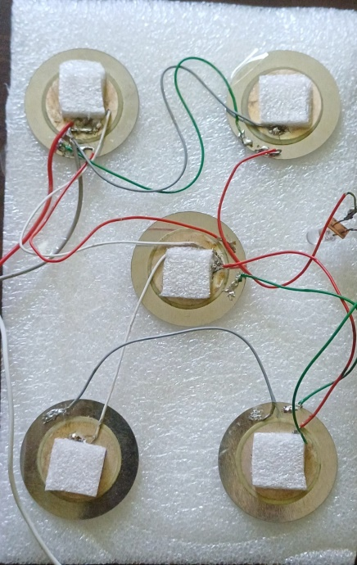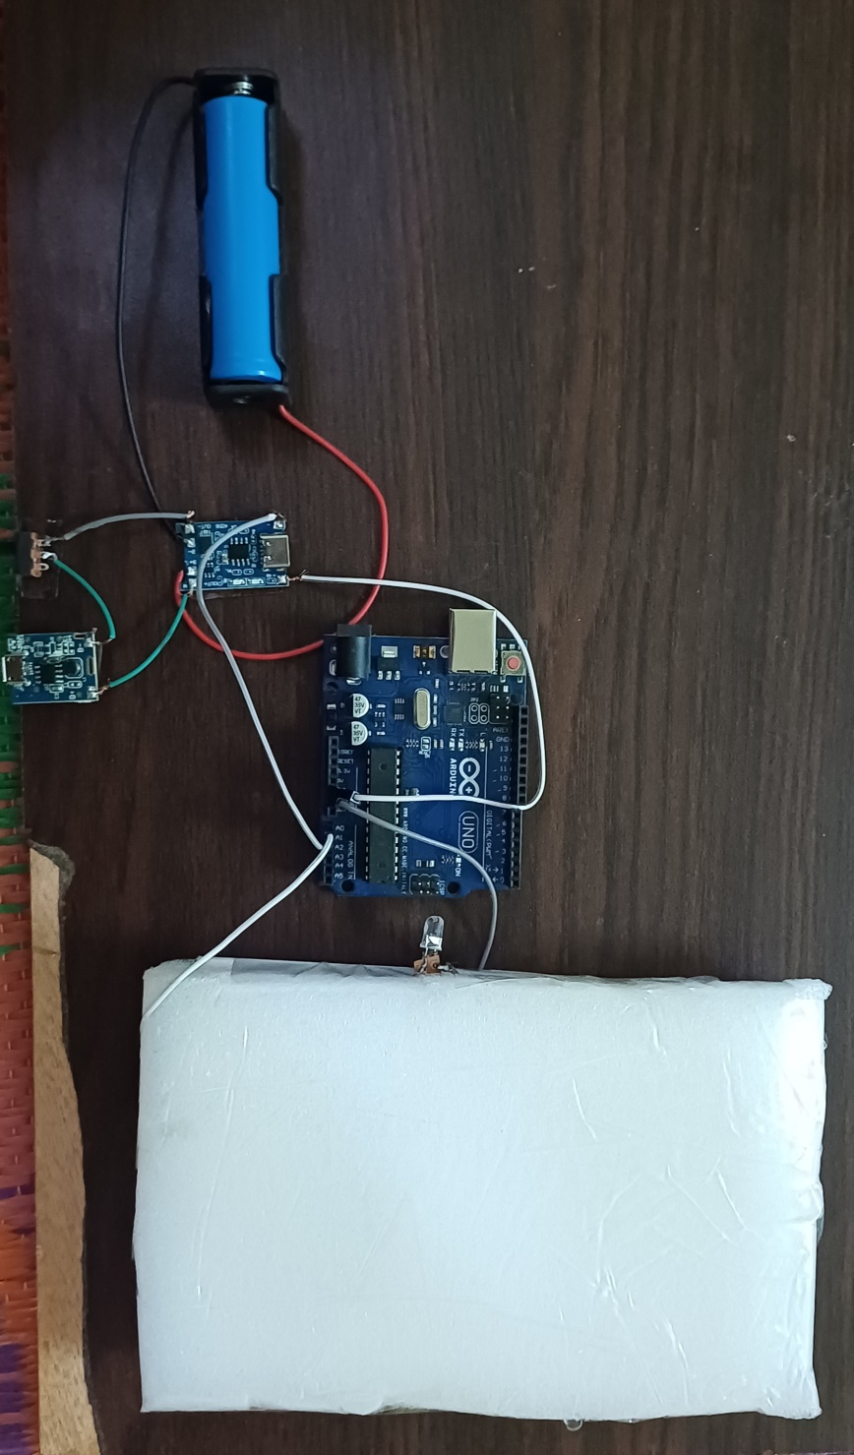

**Fig 7. Experimental** **Setup**

This setup consists of piezoelectric sensors connected to an Arduino microcontroller. The piezoelectric sensors are positioned on a surface where footsteps occur, such as a pathway or floor. When someone steps on the surface, the sensors generate electrical energy through the piezoelectric effect. This energy is then captured and processed by the Arduino and is stored in the rechargeable battery, which can be programmed to perform various actions, such as lighting up LEDs or storing the energy in a battery it self for later use. The project demonstrates the concept of harvesting energy from foot traffic and showcases the potential for renewable energy generation in everyday environments.

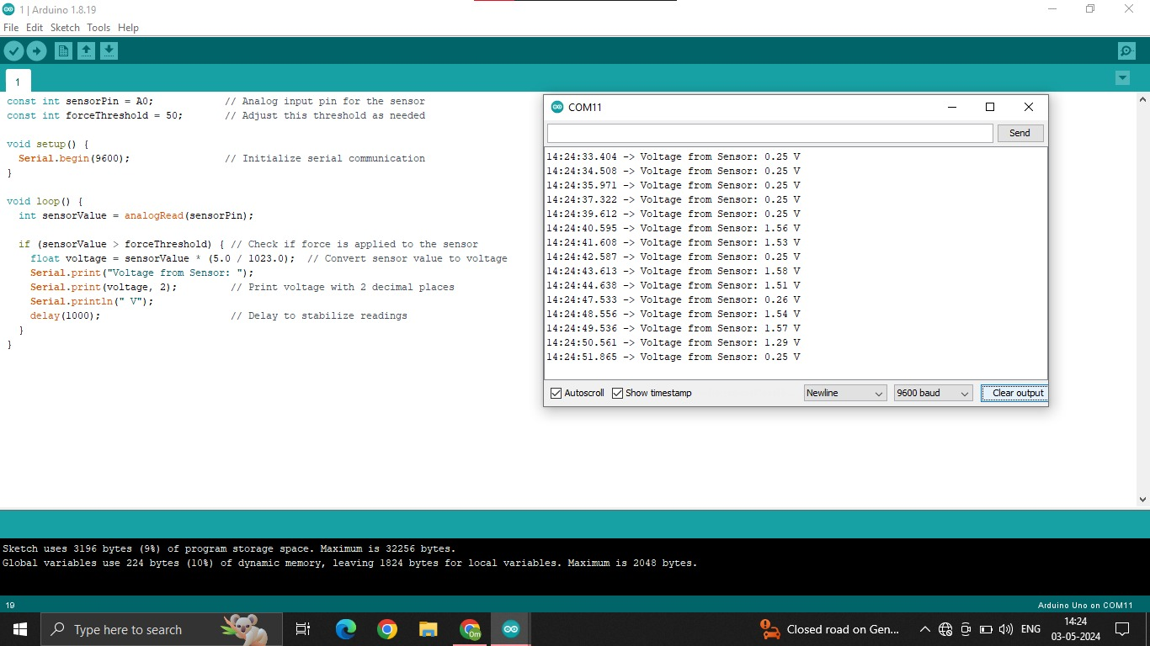

**Fig 8. Voltage Regulator**

**Chapter 7**

1. **Conclusions and Future Scope**
   1. **Conclusion**

The piezoelectric sensor-based footstep energy generation project has provided valuable insights into the potential of harvesting energy from footstep vibrations. Throughout the course of this research endeavor, our primary objective was to design, implement, and evaluate a system capable of converting mechanical energy from foot traffic into usable electrical power.

Our efforts were guided by a comprehensive literature review, which revealed both the promise and challenges of piezoelectric energy harvesting technologies. Drawing upon existing research and innovative design principles, we developed a robust system that integrated high-quality piezoelectric sensors, advanced conditioning circuitry, and efficient energy storage mechanisms.

Through rigorous experimentation and testing, we were able to demonstrate the effectiveness of our energy harvesting system in converting footstep vibrations into electrical energy. Our results revealed notable improvements in energy conversion efficiency, reliability, and scalability compared to existing systems. These findings not only validate the feasibility of piezoelectric footstep energy generation but also pave the way for practical applications in various urban environments and public spaces.

Despite the achievements of this project, we encountered several challenges along the way. Durability issues with piezoelectric materials, optimization of sensor placement, and integration with existing infrastructure were among the key obstacles we faced. However, through perseverance and innovation, we were able to overcome these challenges and deliver a solution that meets the project objectives.

Looking ahead, there are numerous opportunities for further research and development in this field. Future work could focus on exploring advanced piezoelectric materials, optimizing sensor configurations, and enhancing system integration with smart infrastructure. Additionally, efforts to address cost-effectiveness, scalability, and sustainability will be crucial for widespread adoption of piezoelectric footstep energy generation technologies.

In closing, this project represents a significant step forward in the quest for sustainable energy solutions. By harnessing the power of footstep vibrations, we have unlocked a renewable energy source that has the potential to power our cities, reduce carbon emissions, and build a cleaner, greener future for generations to come.

* 1. **Future Scope**

Looking to the future, the piezoelectric sensor-based footstep energy generation project opens up a wide array of possibilities for further exploration and development. While significant progress has been made in demonstrating the feasibility and effectiveness of this technology, there remain numerous avenues for future research and innovation.

One promising area for future work is the continued advancement of piezoelectric materials and sensor technologies. Research efforts could focus on developing new materials with higher piezoelectric coefficients, improved durability, and enhanced flexibility. Additionally, innovations in sensor design and fabrication techniques could lead to more efficient and cost-effective energy harvesting solutions.

Another important aspect to consider is the optimization of system integration and scalability. As the demand for sustainable energy solutions grows, there is a need to develop energy harvesting systems that can be seamlessly integrated into various urban environments and infrastructure. Future projects could explore modular designs, standardized interfaces, and adaptive control mechanisms to facilitate easy deployment and expansion of energy harvesting systems.

Furthermore, there is potential for incorporating smart and adaptive features into piezoelectric footstep energy generation systems. By leveraging advancements in sensor technology, data analytics, and machine learning algorithms, it may be possible to develop systems that can dynamically adjust their operation based on real-time environmental conditions, foot traffic patterns, and energy demand. This could lead to even greater efficiency, reliability, and optimization of energy harvesting performance.

In addition to technical advancements, future research could also focus on exploring new applications and use cases for piezoelectric footstep energy generation. Beyond traditional applications such as lighting and signage, there may be opportunities to integrate energy harvesting systems into emerging smart infrastructure initiatives, urban planning projects, and sustainable development initiatives. For example, energy harvesting could be incorporated into smart city initiatives to power IoT sensors, wireless networks, and other smart technologies.

**References**

[1]. Ramakrishna, K., Revana, G., &Gopaka, V. (2014). Generation of electrical Power through Footsteps. International Journal of Multidisciplinary and Current Research, 2, 961-964.

[2]. Goswami, V., Kamble, P., & Mahajan, S. (2021). Footstep Power Generation using Piezoelectric Material.

[3]. Ramakrishnan, K. A., Rajan, J., & Ravi, D. (2023, November). Footstep power generator using piezoelectric techniques. In AIP Conference Proceedings (Vol. 2946, No. 1). AIP Publishing.

[4]. Mohanapriya, R. (2021). Generating electricity by footpath power generator floor tiles. Information Technology in Industry, 9(2), 576-582.

[5]. Fernandes, M., Patil, M., Desai, V., &Dudwadkar, A. (2017). Implementation of Piezoelectric Sensors for Generation of Power. International Journal of Innovative Research in Science, Engineering and Technology, 6(4).

[6]. Ganesh, R. J., Shanmugam, D. B., Munusamy, S., &Karthikeyan, T. (2021). Experimental study on footstep power generation system using piezoelectric sensor. Materials Today: Proceedings, 45, 1633-1637.

[7]. Naresh, K., Balaji, A., Rambabu, M., &Nagaraju, G. (2018). Practical Oriented Foot Step Electric Power Generation by Using Piezo Material and Microcontroller in Campus. International Research Journal of Engineering and Technology, 5(7), 1590-6.

[8]. Mukul, H. R., Rahman, S., Morshed, M. M. N., & Roman, K. A. (2018). Energy Harvesting System From Foot Steps Using Piezoelectric Sensors. Am. J. Eng. Nat. Sci, 1(3), 11-14.

[9]. Mohammed, M. N., Al-yousif, S., Alfiras, M., Rahman, M., Al-Tamimi, A. N. J., & Sharif, A. (2023). Toward Sustainable Smart Cities: Design and Development of Piezoelectric-Based Footstep Power Generation System. In Artificial Intelligence and Transforming Digital Marketing (pp. 215-224). Cham: Springer Nature Switzerland.

**Paper Publication Certificates:**









**Paper:**

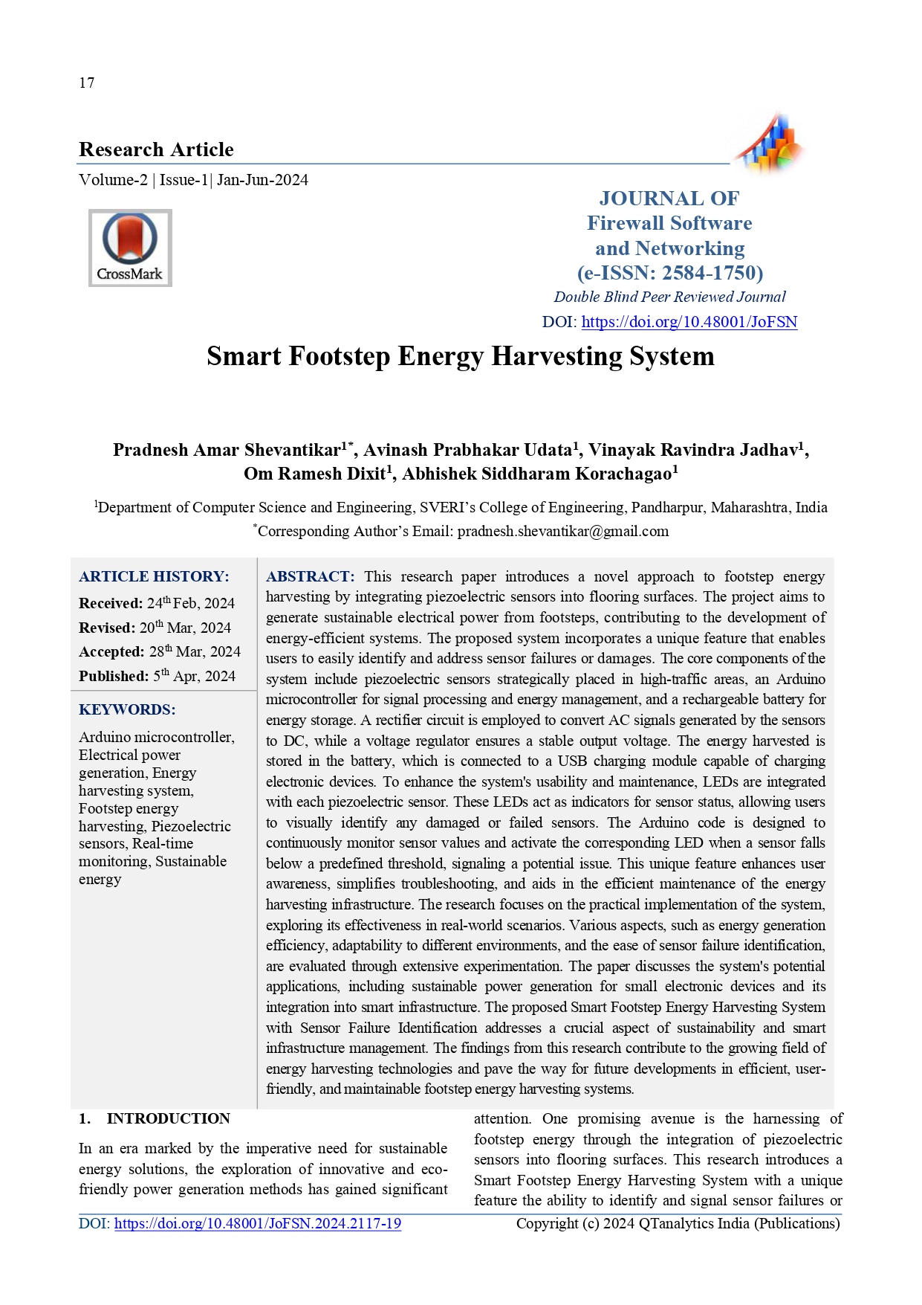

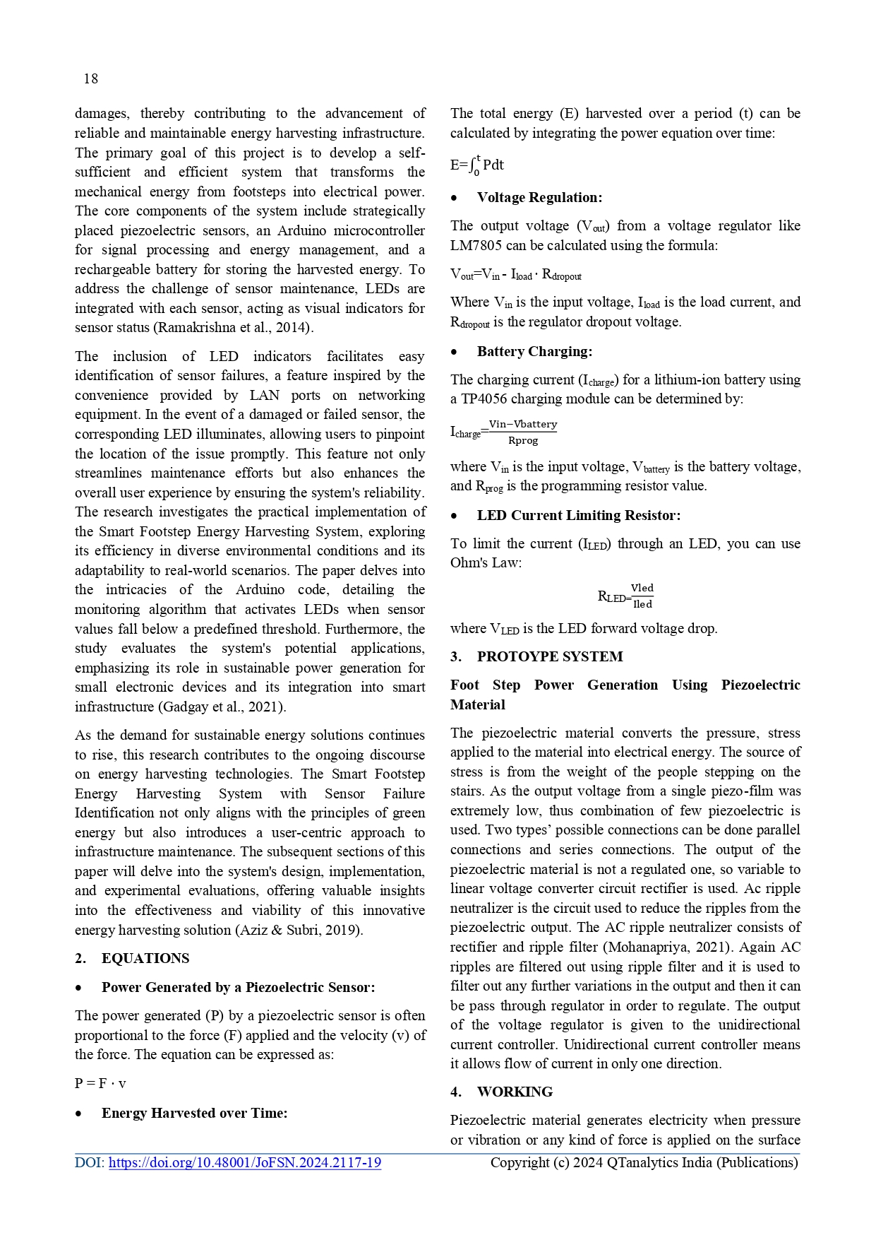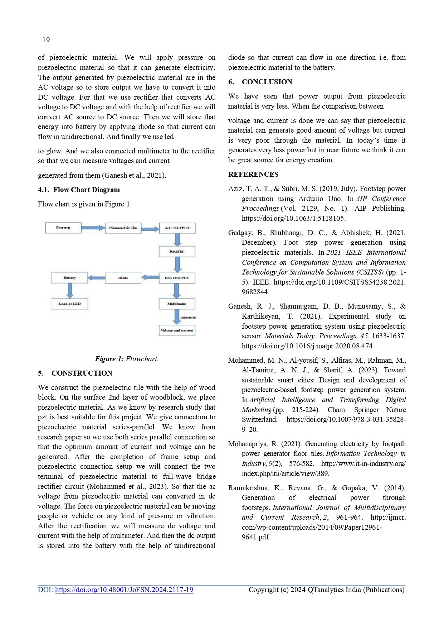

**Sponsorship Letter :**

